FMCA’s 48th South Central Area Rally



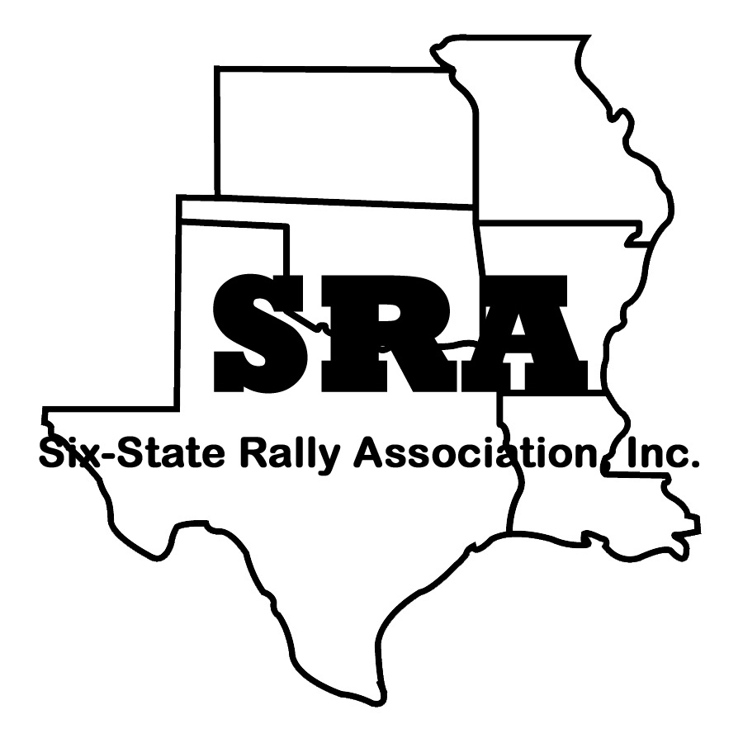

**SI X-STATE RALLY ASSOCIATION, INC**.

2022 Six-State Rally Exhibitor / Vendor REGISTRATION

Heart of Oklahoma Expo Center, Shawnee, Ok, Wednesday, September 14, 2022, through Saturday, September 17, 2022

|  |  |  |  |  |  |  |  |  |
| --- | --- | --- | --- | --- | --- | --- | --- | --- |
| Company Name | | | | | Date | | | |
| Contact Name | | | | | FMCA Member Number | | | |
| Address | | | | | |  | | |
| City | | State | Zip | | | **Credentials are** | | |
| Phone | Cell Phone | | | | **Not Transferrable** | | | |
| Fax | | | | |  | | | |
| E-mail | | | | |  | | | |
| Name and Phone Number of Company Representative (if different from the Contact Name) | | | | | | | | |
| **CERTIFICATE OF LIABILITY INSURANCE REQUIRED WITH REGISTRATION** | | | | | | | | |
| Each exhibitor must carry their own all risk insurance on his property and must be covered by a comprehensive general liability insurance policy providing limits of at least $1,000,000 combined bodily injury and property damage per each occurrence. An Insurance Requirement and Liability Release (mailed with confirmation) must be received at FMCA prior to the event. | | | | | | | | |
| **INDOOR DISPLAY SPACE**  nominal 10’x10’ (Vendor/Service Provider) Includes one table and two chairs. Initial Space | | | | $195.00 | | |  | $ |
| Additional Space Includes one table + 2 chairs | | | | $100.00 | | |  | $ |
| Electric Service for display space | | | | $10.00 | | |  | $ |
| Corner Booth Assignment | | | | $30.00 | | |  | $ |
| ***Please, no presentations using PA equipment allowed in exhibit area.***  ***No product demonstrations outside of booth space.***  **List Product(s) or Service(s):** | | | | | | | | |
| **LIVE-IN RV FEE.** Tuesday thru Saturday (5 nights)  Required if living in a RV on rally grounds.  General Parking, Full Hookups – 30/50 amp | | | | $160.00 | | |  | $ |
| **OUTDOOR DISPLAY SPACE** (Vendor/Service Provider) | | | | $195.00 | | |  | $ |
| Additional Space | | | | $100.00 | | |  |  |
| ELECTRIC (N/A if live-in RV fee applies) | | | | $ 50.00 | | |  | $ |
| **List Product(s) or Service(s):** | | | | | | | | |
| How do you display? (tent, trailer, motorhome, etc.) | | | | | | | | |
| Space size limited – List required space size: | | | | | | | | |
| **EARLY ARRIVAL** – September 11, 2022 Sunday 12 noon pay on site | | | | $ 30.00 | | |  | $ |
| **GOLF CART Rental** (2 pass) Sept 14 thru 17, 2022 (turn in by 5pm ) | | | | $300.00 | | | # | $ |
| **Early pickup of golf carts will have an additional Fee** | | | |  | | |  |  |

|  |  |  |  |  |  |  |  |  |  |  |  |  |  |  |  |
| --- | --- | --- | --- | --- | --- | --- | --- | --- | --- | --- | --- | --- | --- | --- | --- |
| **SPONSORSHIP**: Donations help sponsor rally Events. Special recognition is afforded to major contributors. To be a SPONSOR contact , Commercial Dan Stogner, Commercial Chairman, cell phone: 405-250-9477 email: dan@sca-fmca.com | | | | | | | | | | | | | $ | | |
| Event Examples: Volunteer/Vendor Cookout ($700) Ice Cream Social, ($500) Evening Entertainment, ($1000) First Timers Reception ($200) Ladies Luncheon ($300), Trams ($300) Breakfast ($1000), Water/Ice ($100) | | | | | | | | | | | | | | | |
| **PROMOTIONAL LITERATURE DISTRIBUTION**  (for distribution in attendee’s Goodie Bag and available at the Information Table) | | | | | | | No charge | | | $ | | | | | |
| Ship Clearly Marked material to arrive between, September 3rd and September 11, 2022. Shipping address:  **Heart of Oklahoma Expo Center Address: 1700 W Independence St, Shawnee, OK 74804** | | | | | | | | | | | | | | | |
| **PROGRAM ADVERTISING – Souvenir 48th Annual Program Book First come / First served**  **Ad Copy Deadline Date – August 12.** E-Mail ***camera-ready high-resolution jpg ad*** to both [rallyprogram@fmca.com](mailto:rallyprogram@fmca.com) ***and*** cgkennington@att.net. Address program book questions to Charley Kennington at email or 254-230-7302. Publication of ads received after the deadline date cannot be guaranteed. | | | | | | | | | | | | | | | |
| 🞎 Back Cover (glossy, color) | | | | | 7” wide x 10” tall | | | $300.00 | | | $ | | | | |
| 🞎 Inside Front Cover 🞎 Inside Back Cover (glossy, color) | | | | | 7” wide x 10” tall | | | $300.00 | | | $ | | | | |
| 🞎 Inside Full Page (color) | | | | | 7” wide x 10” tall | | | $200.00 | | | $ | | | | |
| 🞎 Inside Half Page (color) | | | | | 7” wide x 5” tall | | | $125.00 | | | $ | | | | |
| 🞎 Inside 1/4 Page (color) | | | | | 3 1/2” wide x 5” tall | | | $ 80.00 | | | $ | | | | |
| **SEMINAR / WORKSHOP Presentation Request (Maximum: 2 per Vendor)**  Tech/Non-Tech/Craft (Attach additional sheet if necessary ) 1 hour time periods | | | | | | | # | | | No Charge | | | | | |
| Seminar Title: | | | | | | | | | | | | | | | |
| Name of Presenter: | | | | | | | | | | | | | | | |
| Expected Attendance: A/V Equipment Used: | | | | | | | | | | | | | | | |
| Handout Material: | | | | | | | | | | | | | | | |
| Description for Program: | | | | | | | | | | | | | | | |
| Seminars are blocked in 1 -hour time periods. Seminars are for the edification of the members and should be generic. Presenters should plan to have their own presentation equipment. Multiple seminars available only as time and space permits. Sales of a product or service may not take place in a seminar session or for membership gathering. The sale of a product or service may only be made in the exhibitor booth or on site of an outdoor vendor if appropriate fees have been paid. Deadline for seminars is **August 24., 2022** | | | | | | | | | | | | | | | |
| **NAME BADGES** (Please print clearly and attach additional sheet if necessary)  **Company name, city, and state will be included.** | | | | | | | # | | | No Charge | | | | | |
| (1) | | | | (3) | | | | | | | | | | | |
| (2) | | | | (4) | | | | | | | | | | | |
| **Cancellation/Refunds:** Registration cancellation requests must be received no later than September 20st. Refund requests will be processed within 30 days of receipt of the cancellation request and are subject to a non-refundable $55.00 handling fee and $40 per booth fee, if applicable. | | | | | | | | | | | | | | | |
| **PAYMENT INFORMATION: Make Check Payable to *FMC, Inc.***  **Mail to: South Central Six-State Rally Association c/o FMCA, 8291 Clough Pike, Cincinnati, OH 45244**  **Fax to: 513-474-2332 or 800-543-4717 Event Services Department 513-474-3622 or 800-543-3622**  **Credit Card Information: Discover MasterCard Visa American Express** Card Number Expiration **Signature TOTAL**  $ | | | | | | | | | | | | | | | |
| Display space will be assigned based on several factors including, but not limited to, when your paid registration is received. | | | | | | | | | | | | | | | |
| **Herman Mullins** | **Dan Stogner** | **Dianna Huff** | | | **Katy Lacy** | | |  | | | | |
| President | Northern Vice President | Rally Master | | | Seminar Captain | | | | | |  | | |
| 214-679-7791 cell | 405-250-9477 cell | 405-641-8226 cell | | | 214-500-8146 | | | | | |  | | |
|  | dan@sca-fmca.com |  | | | nsrobertlacy@gmail.com | | | | | |  | | |